**SAE 1.03**

*Deliverable 1 – Case study and Roadmap*

**Installation of a Dual boot:**

_________________________________________________________________

First off, you will need to create the bootable USB drive, which allows next to install Ubuntu, so, for that you will need a USB drive, of at least 4GO to be safe.

To create your bootable USB drive, you will have to go to the Ubuntu website and download the latest version of Ubuntu (<https://ubuntu.com/#download>).

Then, you need to download a software such as **Rufus** which will allow you to install the file that you just downloaded on your USB drive. Once it is downloaded, open the Rufus software, and in the ‘Peripheral’ section, select your USB drive. Next, in ‘Type of start’, just select the file that you just downloaded and then, click on ‘Start’.  
  
Now that your USB drive is a boot of Ubuntu, you will need to restart your computer. Make sure your USB key is plugged in on one of the USB ports. Be careful when you restart your computer ; you will have to enter the BIOS, the access keys can change depending on your motherboard, but usually, the keys are F2, F10, F12 or DEL. Once you’re on the BIOS, you will have to find the BootLoader and choose to boot on your USB drive and not on the ‘Windows Boot Manager’ if you are on Windows.

Finally, save your changes and exit the BIOS. Your computer should restart automatically (See action ‘Installing Ubuntu’ for the rest of the installation).

**Installing the VM**

_________________________________________________________________

First of all you will have to download the .iso file of the distribution you want. In this case, we will take the latest version of Ubuntu (<https://ubuntu.com/#download>).

Then, download the VirtualBox software: (<https://download.virtualbox.org/virtualbox/6.1.30/VirtualBox-6.1.30-148432-Win.exe>).

Once all this downloaded and installed, open the software 'VirtualBox', you will arrive on an interface like this:

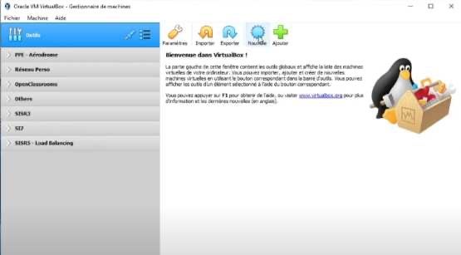

Now, you will have to click on ‘New’ to create a new virtual machine and then you will see this on the screen:

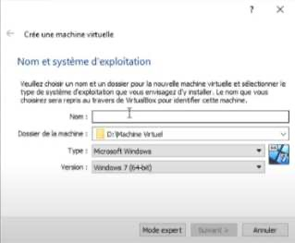

It will be important for you to put the name, the folder of the machine, the type and the version.

In our case, we are going to put the name ‘Ubuntu’, in the folder where we want to install the machine, put ‘Linux’ in the type, and choose the ‘Ubuntu (64-bits)’ version.

Then, click on ‘Next’. Now you are going to have to choose the memory you want to dedicate to the VM so you either play with the slider or directly put a precise number that you want in MB. Then, click on ‘Next’.

Now the screen shows you what hard disk positioning you want, if you already have an existing virtual hard disk file, choose the option and choose the file. Otherwise, choose ‘Create a virtual hard disk now’. Then, you’re asked if you want a ‘Dynamically allocated’ or ‘Fixed size’ hard disk. ‘Dynamically allocated’ will be faster to create but there could be losses of performance, and ‘fixed size’ it takes longer to create but it’s easier and faster to use. Then you have to choose for the location of the file and its size. You can modify it if you want, but in our case, we will pass and click on ‘Create’.

Now you have successfully created your VM. However, you can’t launch it yet, you will find it here:

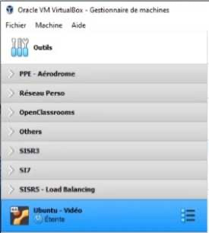

Now, you have to go to ‘Conifguration’ then to ‘Storage’ and click on ‘Empty’ in ‘Controller: IDE’. Then, on the right side, you will see this:

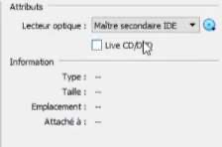

Click on the button on the right of the optical drive (The disk Blue), that opens you several possibilities, here we are choosing the 'Choose a disk file ...' option. Remember, as we said earlier, you had to download a .iso file from Ubuntu, here you have to find it and click on it. Once that is done, go to category, then set the 'Network access mode' to 'Bridge access', then click on the advanced bridge, then click on the advanced options. Once this is done you will see many options appear. Now change the Promiscuity mode to 'Allow All'. Now you can close and click on 'Start' your VM. Now you just you just have to finish the installation of Ubuntu normally (See section Installing Ubuntu' section).

**Installing** **Ubuntu** _________________________________________________________________

Now, only the installation part is left (ONLY Ubuntu). Once arrived on the installation, it will be necessary for you to choose the language (The selector on the left), select your language and if you want to test, just click on 'Try Ubuntu' otherwise click on 'Install Ubuntu'. We will select 'Install Ubuntu', because we want to install it. Now you find yourself on the keyboard layout, select the positioning of your keyboard (here we are in France so we are going to select 'French' and 'AZERTY', but you can have keyboards of other languages). Be sure to test your keyboard because you will need it. Click on ‘Continue’. Now you are on a page called 'Update and other software', here you are asked for several things. First of all, if you want a normal or minimal installation, take the normal one, you never know, the minimal is used to have no software to install when you are on the desktop, but it is better to take the normal one, and just below this part is for the drivers. In fact, you'll be asked if you want to install third party drivers or not like the NVIDIA drivers (the Linux community is not a big fan of things that are closed like drivers, so it doesn't check directly but it is very useful) so we advise you to check 'Install third party software for graphics hardware ...'. However, you are asked to enter a password called 'Secure Boot'. Then, you need to specify the type of installation you want. There are many possible choices 'Remove ...' 'Erase disk ...' 'Reinstall ...'. These three are options if you already have a Linux to install. If not, you have other choices like 'Install' or 'Other thing', we will take 'Other thing' to be able to have the choice of sizes, then click on 'Continue'.

Now you arrive on the most difficult part, but we are going to go there step by step. So you have to find the free space (Either a new hard disk that you have installed on your computer or you have free space on an existing hard drive, do not use WINDOWS hard disks, or it will replace your original Windows). Once you have found the free space, you will have to create several partitions with the button '+' located at the bottom of the page. The first partition created is for the installation of the OS so here Ubuntu in general everyone gives approximately 50 GO, after modifying the size, do not touch nothing more except the 'point of assembly' or you must put '/root'. Then you have to recreate a new partition the SWAP. For this, it is not needed more than 8 GO for the size, and then modify the selector 'Use as' and put in ‘swap space'(« swap »). Finally, the last partition to create is the home, so you put all the remaining space and in 'mount point', put '/home'.

Congrats, you have just done the most complicated part now we are at the end.  
Finally, you just have to click on 'Install now' and then put ‘Continue' and again, 'Continue'.

Then you will be on a new page and click on your country (here, 'France') then click on 'Continue'. Now you are on the part of the name and password. So enter all the information requested on your name, the name of the computer , the password, ... then click on 'Continue', and now you just have to wait until the installation finishes then you will arrive on your Ubuntu.